
Web enabled automation station
The task The solution
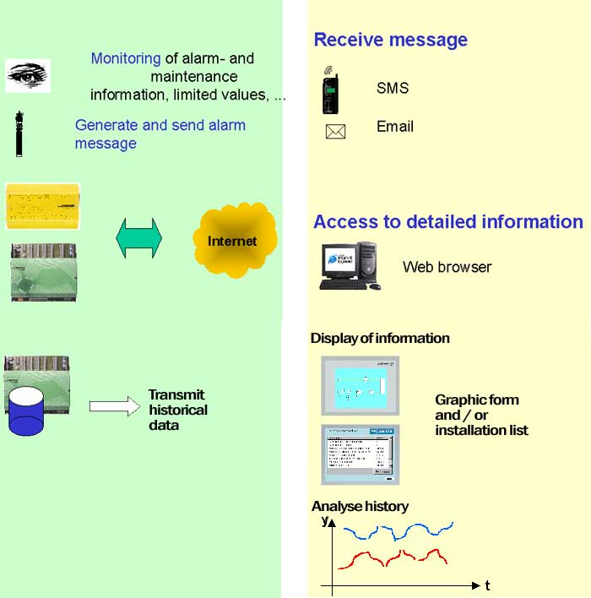
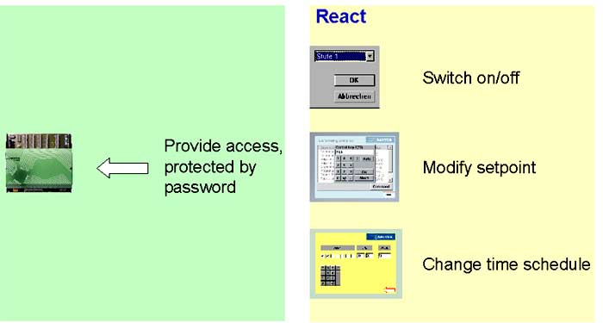

The solution (1)
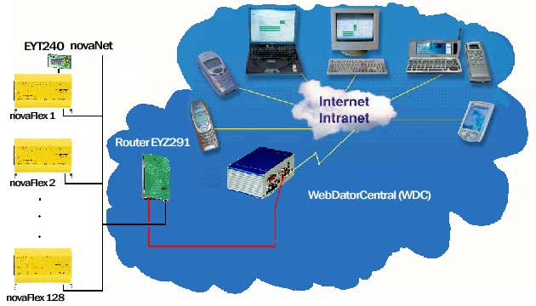

Connectivities

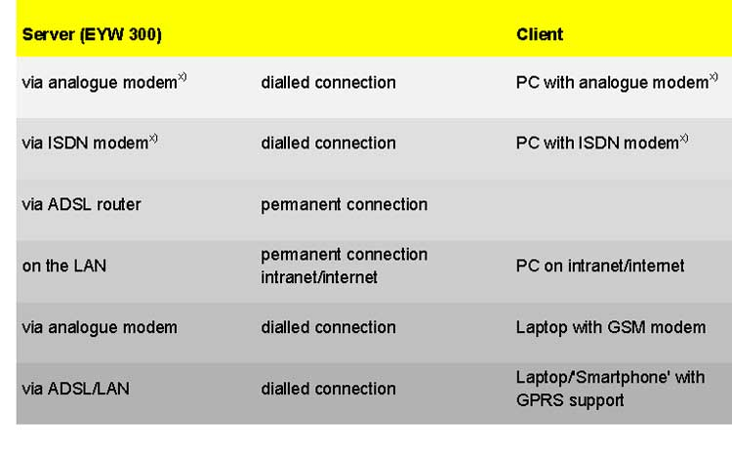 x)with a 'hybrid modem' for different pairings on the server/client side

The solution (2)
Standard Embedded Web Technology
and
HVAC application

•Display Data and Status Information
•Set Data (DataPoints)

•
Alarming
•Process and Display Historical Data
•Application and Engineering as simple as possible
(comparable with our BACnet solution)

Overview of functions (1)
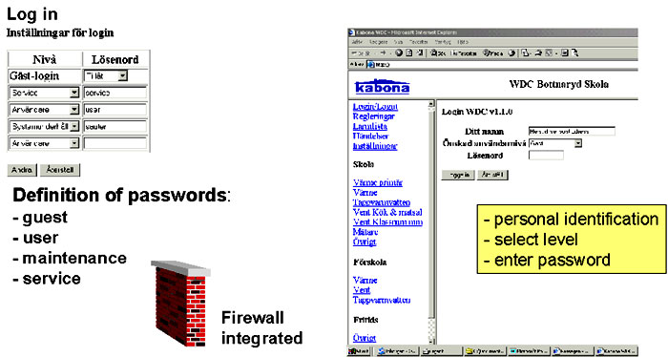

Overview of functions (2)

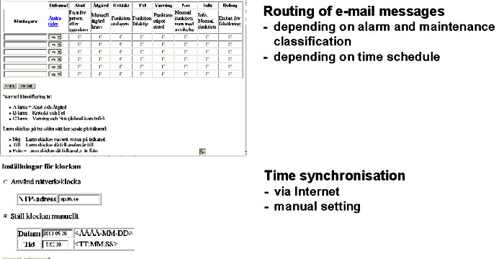

Overview of functions (3)

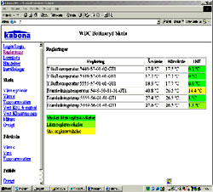
Monitoring of control loops
Display of:
- actual values
- setpoints
- control deviation
3 levels shown with different colours

Overview of functions (4)
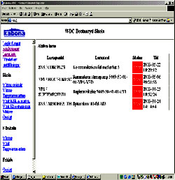
List of ”active alarms”
Presentation with:
- house address
- address text
- status:
> active, not yet acknowledged
> active, acknowledged
- time of occurrence

Overview of functions (5)
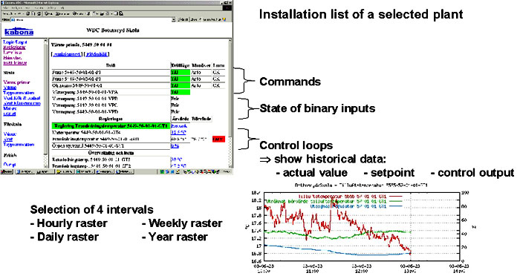
Overview of functions (6)

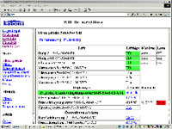
Dynamic display of process variables, alarms, ...

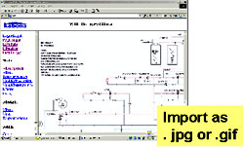
No ”active pictures” because of ”simple
Web clients” and slow datarate (9,6 kBd)

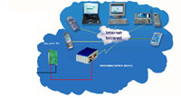

Overview of functions (7)
Schedule and calendar
- 4 switching-points/day
- weekly program
- exception days
- exception periods

Overview of functions (8)
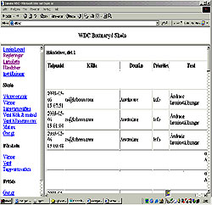

Log of remote access
- date and time
- identification (see login)
- level (user, service, ...)
- priority
- additional explanations

Overview of functions (9)

Engineering

Following some rules defining the “house address“, there is no need of additional engineering.

After initialisation (switch on the novaWeb), novaNet is scanned automatically.
The connected stations are detected and their house addresses, address texts, card codes etc. are monitored and stored as a ”database” in the novaWeb.All information is displayed in lists with a predefined structure.
The length of the list adapts automatically to the number of entries.

The solution is available in different languages.
Example of an plant view (in English)
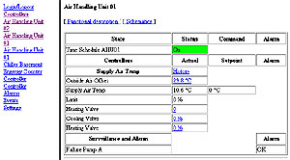
Access to the Sauter demo installation in Basel
http://embweb.sauter-headquarter.ch
