
New range of unit valves
A competitive product
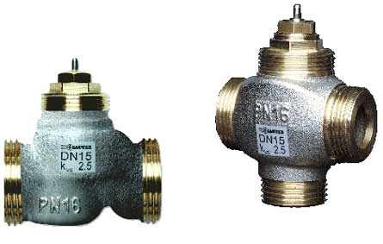
New range of two-way valves
VUL010, VUL015, VUL020. Comparison with the VXL
The response to our competitors
Male thread on both connections

Characteristic curve is equal percentage with sealing on the plug

With Sauter logo
Nominal pressure, kvs shown on the valve

Same action as VXL valve

With 4 mm stroke
For Sauter thermal drive, 2-point or continuous

The valve’s characteristic
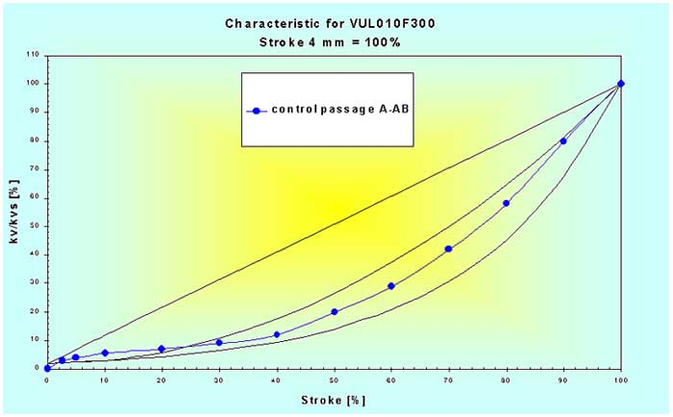

The valve‘s stuffing box can be replaced even when the installation and the valve are under pressure.

Nickel-plated body for all versions.
Design matches the continuous drive.

Large stroke of 4 mm with excess stroke;
foreign bodies and wealding beads can be flushed out.

A regulating valve at a lower price than an ON/OFF radiator valve

Sectional drawing VUL
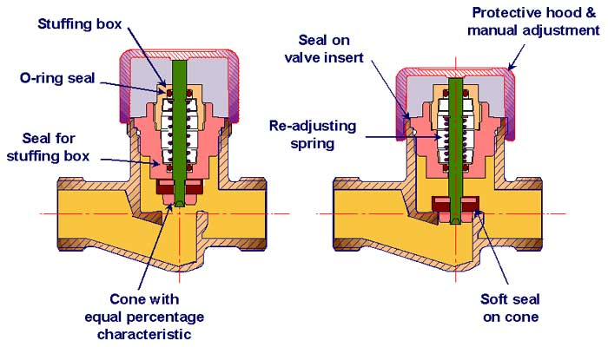

New range of three-way valves BUL010, BUL015, BUL020
Why the change?
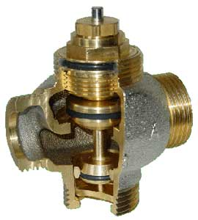

Geared towards our competitors.
Common type of connection

Characteristic curve is equal percentage
with double plug and double sealing

The valve’s action is the same as the VUL valve

With Sauter or customer logo.
Nominal pressure, kvs shown on the valve

With 4 mm stroke.
For Sauter thermal drive, 2-point or continuous

The valve characteristic
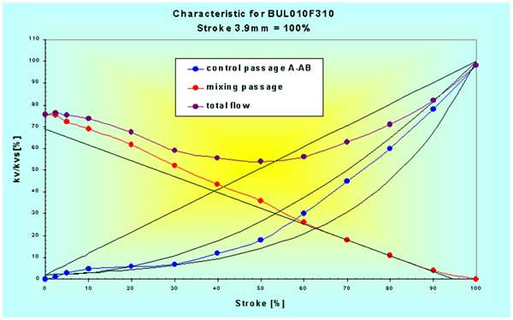

A top hit
A range of products that can be used for both fan-coils and chilled beams, or for individual-room control in general.

Nickel-plated body for all versions.
Design matches the continuous drive.

Suitable as a control valve, a diverting valve or a change-over valve with high throughflow.

A very inexpensive regulating three-way valve, suitable for the OEM market.

Sectional drawing BUL

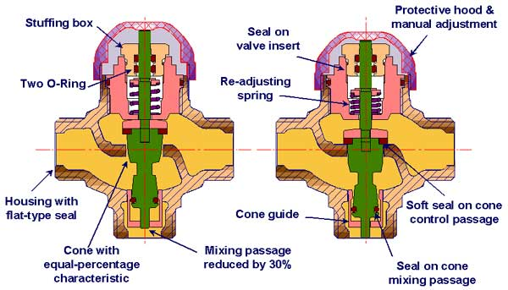
New range of unit valves.
Two-way valve
Three-way valve with and without bypass.

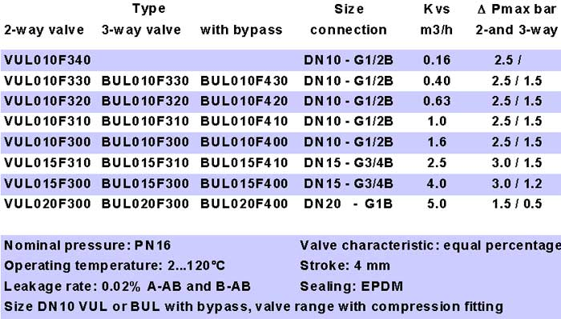

Valve charts

The wide range of applications provides great versatility

If you keep to the ‘recommended range’, you will have:-
•a valve that operates quietly
•excellent valve authority
•a valve that will have a long serviceable life

Easy to choose the right drive, since all the valves close in the same direction

Connection possibilities
