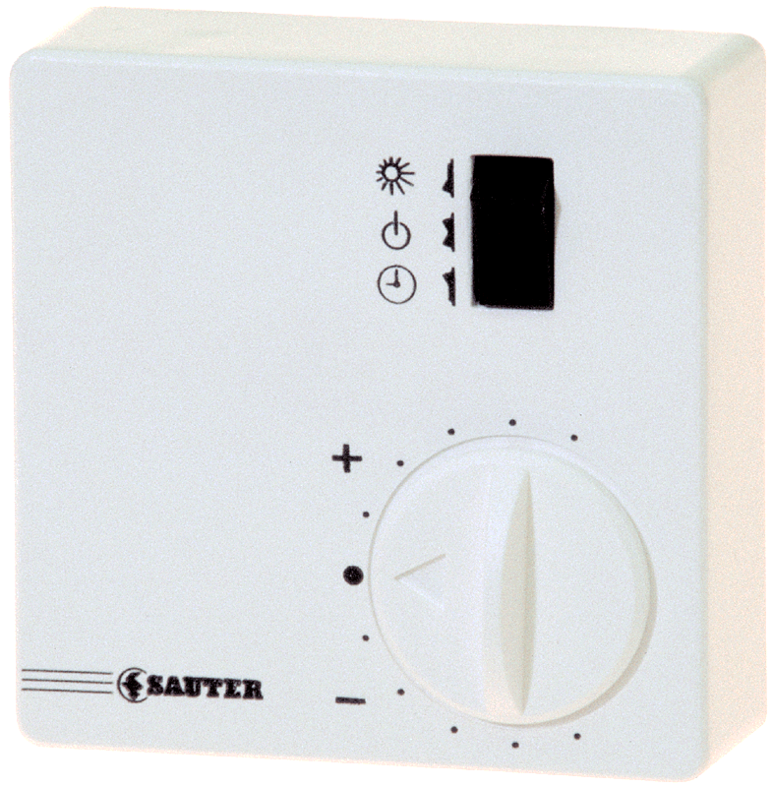
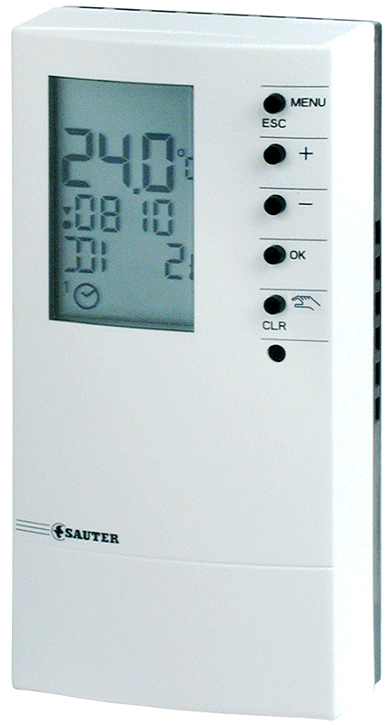

NRT 114 with EGS52/15
Remote control unit EGS52/15 for NRT 114 to:
- switch the operating mode
- adjust the setpoint of the room temperature
- work with external room sensor

