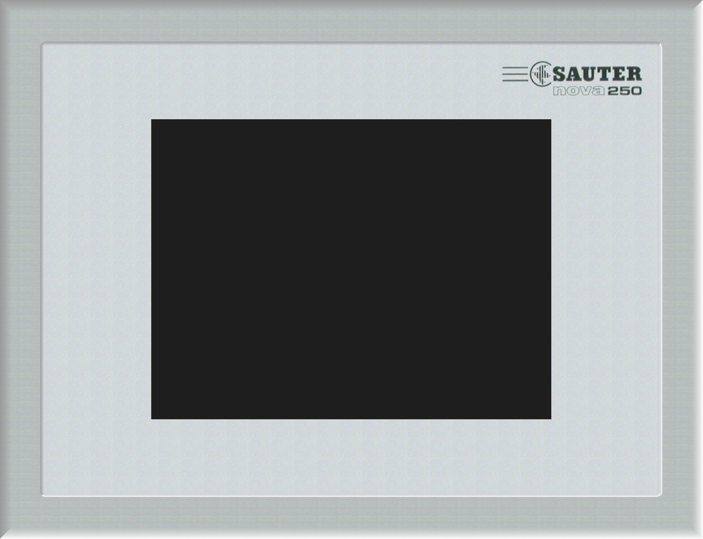
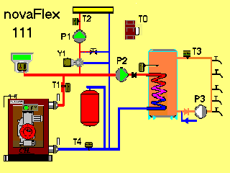

The EYT 250 touch-panel

and its main functions
- Selection of schematics and installations
- Dynamic portrayal of:
- Alarms
- Measured values and setpoints
- Commands with feedback signals
- Hours-run counters
- Quantity counters
- Easy to view and adjust the time programme in the AS
- Graphic portrayal of the HDB in the AS
- Analogue values
- Binary signals
- Automatic generation and portrayal of installation lists, without particular effort, through ‘researching the system’
- Configuration program with interface to CASE-Prj for designing schematics, for viewing values and for navigation (buttons etc.)

