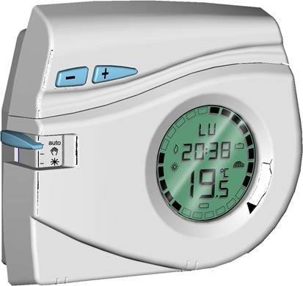
Electronic Room Thermostat EC 3000
At present exist 10 to 14 items to cover the requirements
and this by each manufacturer
Digital:

24 hours - battery
Weekly - battery
Radio - battery
24 hours - 230 V~
Weekly - 230 V~
24 h. 2wires - 230V~
Weekly 2wires - 230V~
Analog:

24 hours - battery
Weekly - battery
Radio - battery
24 hours - 230 V~
Weekly - 230 V~
24 h. 2wires - 230V~
Weekly 2wires - 230V~
Market Analysis
>> Reminder of the market requirements:
- The wholesalers want to reduce the stock: less items to cover all the market segments and applications
- The installers look for the optimization of their installations: easy to fit and to set
- The end-users request above all for: a nice design, simple to use and a reliable product
- Competitive price

