Remote control? Which is the best solution?

Solution: MODEM / ISDN
Remote control software

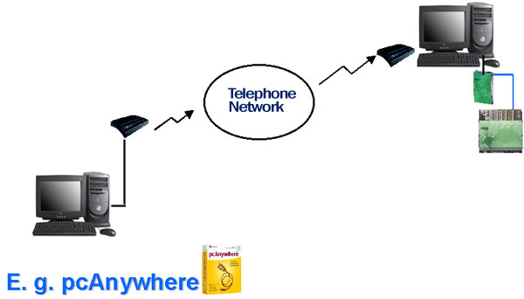

Solution: MODEM /ISDN

Remote control with nP, nP32,Npo
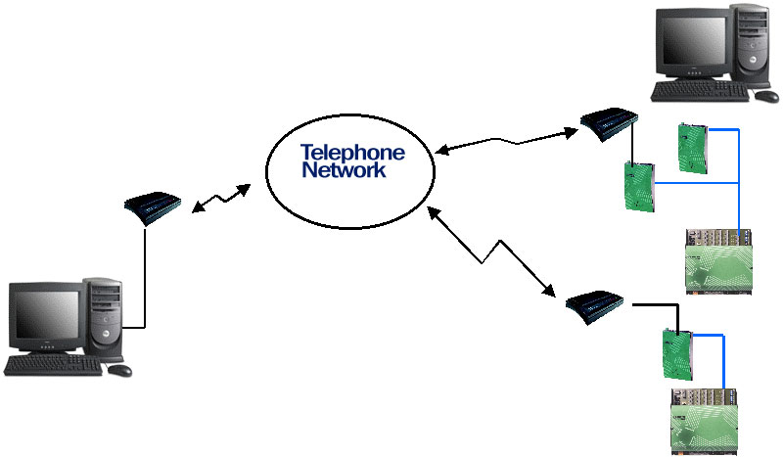

Solution: HSCSD

Remote control with nP, nP32,nPO
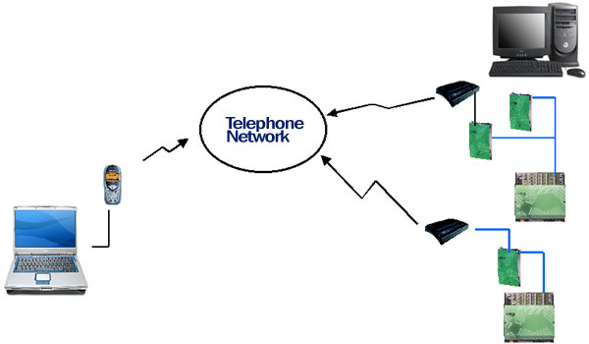

Solution: WAN

Leased line TCP/IP
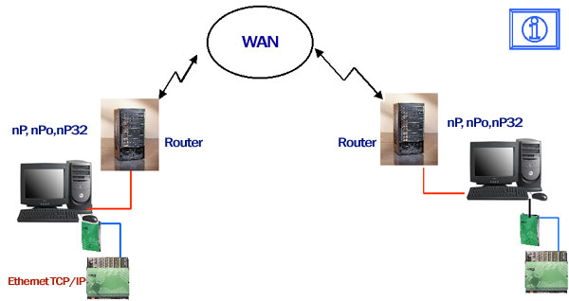

Solution: Internet Web server

Leased line
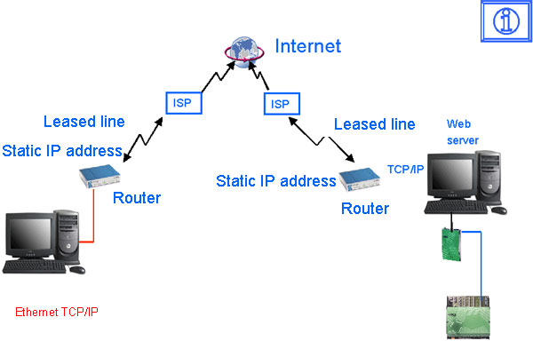

Solution: Internet Web server

Leased line and alarm transfer
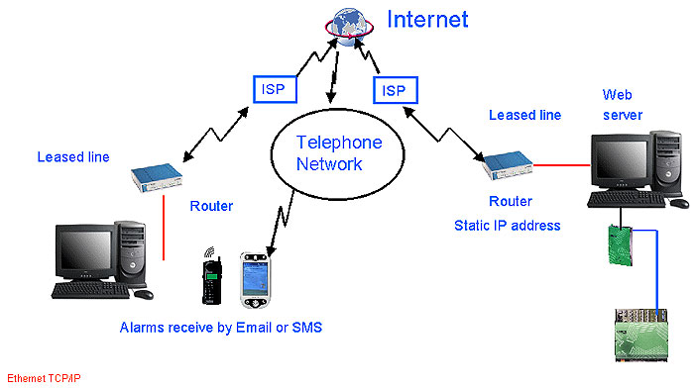

Solution: Internet Web server

Dial up line
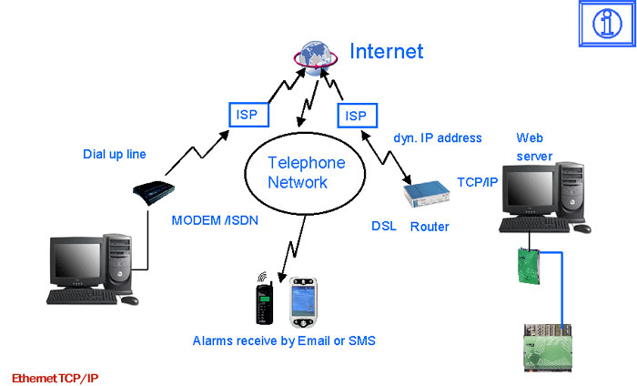

Solution: Internet WEBserver

GPRS
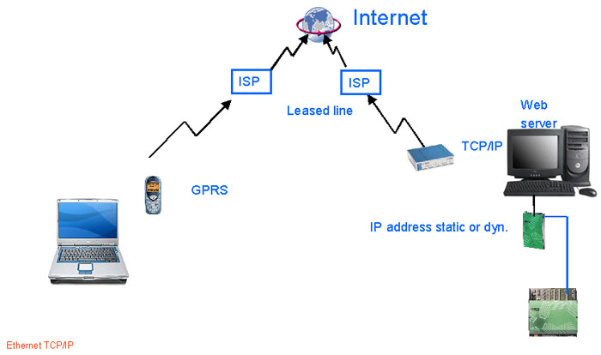

Questions
Where do you want to have access from?
How often do you need the access?
Which functionality do you need?
Are there some devices that we can use?
What happens in case of alarm?
How much money do you want to invest ?

Decision
Internet solution

Advantages
Cheap connection from everywhere

Cheap for long-term connections

Disadvantages
Administration costs
Security problem (Virus)
Knowledge

Decision

Dial-Up connections

Advantages

Low administration costs
No security problem (Virus)
Easier to handle

Disadvantages

Expensive for long-distance connection
Expensive for long-term connections

Security
Do we have a profound knowledge to offer it?
Do we have a profound knowledge to install it?
Do you have a supplier?
Who will be responsible for the updates?

What is a Firewall?

A firewall is a single point between two or more networks through which all traffic must pass (a checkpoint) with which traffic can be controlled and often authenticated and in which all traffic is logged"
Firewalls can be grouped into several classes, e.g.:

packet filters
stateful inspection firewalls
application level firewalls / proxies

Virtual Private network

Data packets are first encrypted for security, and then encapsulated in an IP package by the VPN and tunneled through the Internet

What is a Firewall?

Translates local IP addresses in a outgoing IP address. You can give rules what should be allowed to do in the internet.

Communication standards
SDSL Symmetric Digital Subscriber Line max 2,048 Mbps

ISDN Integrated Services Digital Network max 64KBit/s

HSCSD High Speed Circuit Switched Data 28.8 kbps

ADSL - Asymmetric Digital Subscriber Line Downstream 768 KBit/s Upstream 128 KBit/s

GPRS General Packet Radio 53,6 kBit/s

Leased lines Flexible range of bandwidth/interface options (155Mb/s to 2.4Gb/s)

CATV range of bandwidth/interface options (Downstream 512Bit/s-4MBit/s Upstream 128 KBit/s-1024KBit/s) Protocol DOCSSIS

IP address
Static IP addresses are numeric addresses that uniquely identify your computer(s) on the Internet.

Dynamic IP: The Dynamic DNS service allows you to alias a dynamic IP address to a static hostname in any of the many domains we offer, allowing your computer to be more easily accessed from various locations on the Internet. You can use e.g. http://www.dyndns.org

Internet

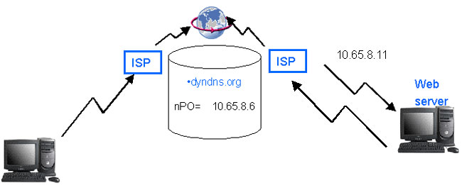
nPO.com Service dyndns
(proof if the IP has it changed.)

