
novaPro

NEWs
novaPro Open
novaPro Event Viewer
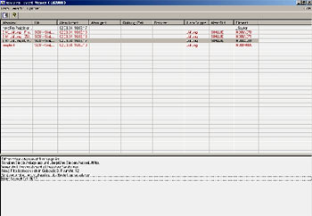
Popup window with sound
Possibility to deactivate alarms
Filter functionality for house addresses

novaPro Event Viewer Editor
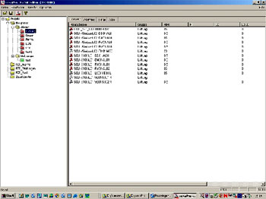
32 Bit application
Easier creating of the alarms

Workstation with Terminal-Client`s
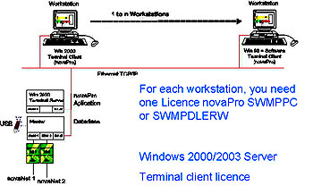

Workstation with Terminal-Clients

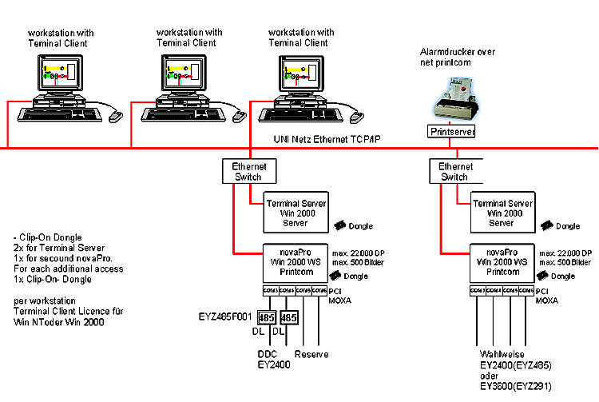
novaPro SAIA PCD

SAIA PCD communication DLL Version SP2.0.88
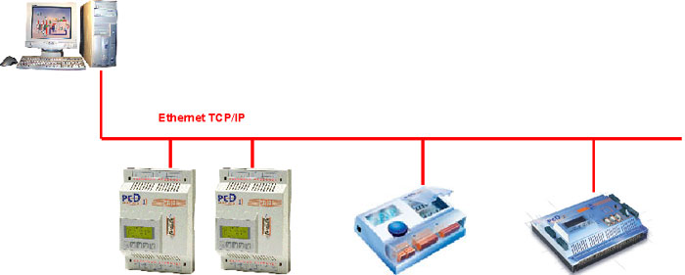

novaPro E-bus

Driver for E-Bus

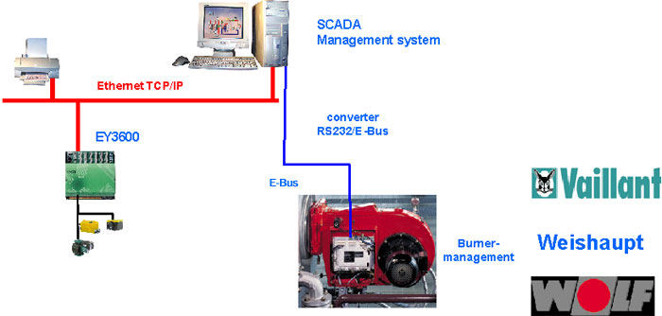

novaPro Jean Müller PL-Master

“Powerlizer“ comprises a complete product range for the acquisition of measured values and the display, monitoring and evaluation of these values in power distribution systems for industry and electricity supply companies.
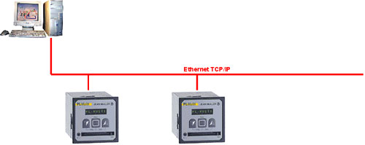

novaPro TagMapper

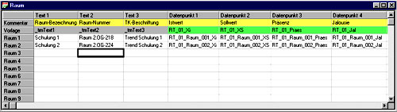
You have the possibility to see the values of 255 different rooms in one picture.

novaPro SQL server

Easy export from online values to SQL server available June 2004
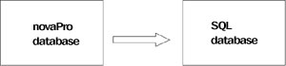
Database system MSDE

eRCD virtual room operating unit
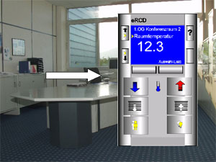
Easy operating like a room operating unit:
- Room temperature
- Sun blinds
- Light
- max. 15 DP
-
-
available June 2004

novaPro preview

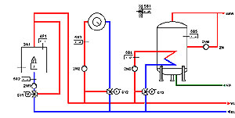
Plant protocol including plant picture
available end of 2004

Complete graphic functionality
available middle of 2005
max. number of datapoints 65000

novaPro Open ZP2400
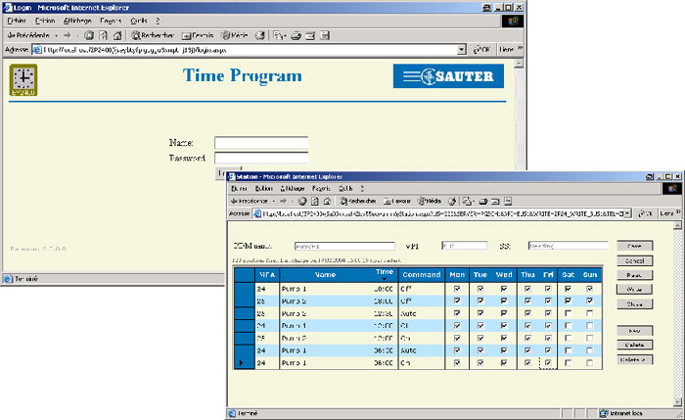

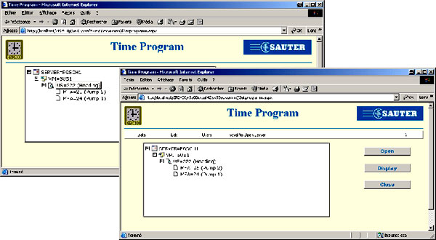

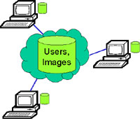
Centralized application

–Centralised Images

–Local Backup for User Management

novaPro Open SQL server

Centralised SQL Server – Based User Management
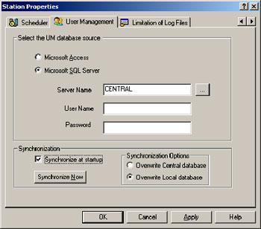
The user now has a choice of using Microsoft Access or SQL Server for user management.

novaPro Open WEB Logout
Auto Log-Out on Inactivity Mechanism in Web
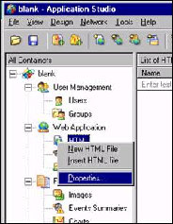
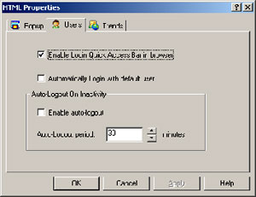

novaPro Open Limitation
Limitation of size of novaPro Open online and historical logfiles
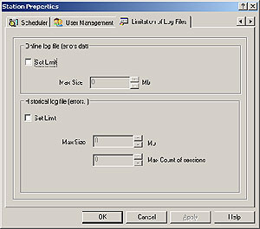
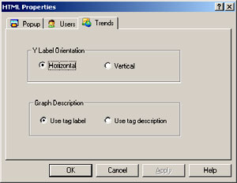
novaPro Open Trend Label
Trend Label Display Functionality

novaPro Open 1.12 allows a vertical display of a tag description on a trend.

novaPro Open Virtual keyboard

Virtual Keyboard available in the WEB
In the Web login window, a new button will be added, that displays the virtual keyboard.
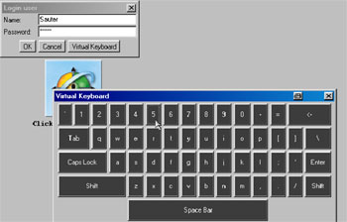

Event Window
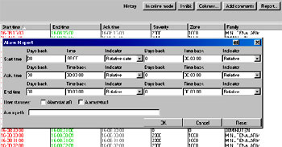
History mode respects filter setting
-higher security
–
Tuneable warning, if filter result contains too many alarms
-higher program stability

NovaScheduler
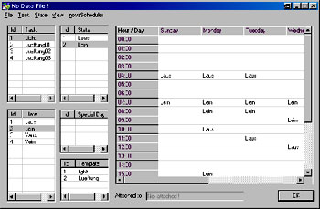
Off-line Configuration

–
Import / Export

–
Copy / Paste

–
Fast configuration of novaScheduler time programs

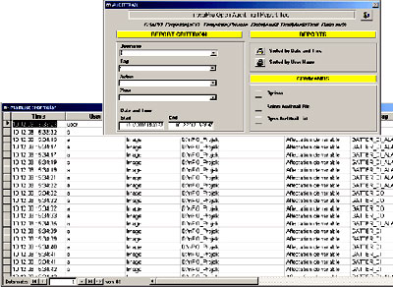
Audit Trail

Audit Trail reporting tool

–fulfils requirements of
FDA CFR21 Part 11
–write-protected

based on Microsoft Access

integrated in Template Project

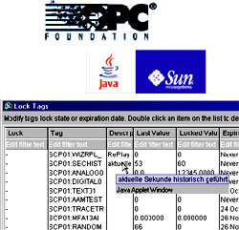
etc.

OPC Client Data Access and Alarm Event

Backup Mechanism for History Logging

Support of Sun Java VM

Tag Lock Window with tool tip

Send system alarms through AAM

Automatic application update

The future of novaPro Open
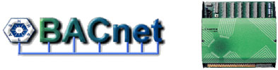
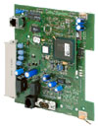
Alarm handling

novaScheduler for BACnet
–Support of Schedule- and
Calendar Object
–
History Data Access
–Support of Trend Object

Buderus Logamatic 4000 an nova230
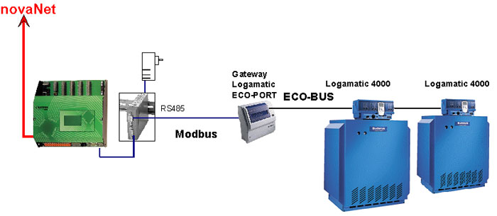
Connection between EYL 230 F040 and Logamatic 4000 control system over Modbus-RTU Protocol.

