
EYT250 touchpanel
TPC vers 1.0.8 (Touch Panel Configurator)
update of EYT250 operating system and program can be done directly with TPC

EYT 250 new service release 1.2.2
new password functionalities (guest, user, admin incl. 6 passw.-levels)
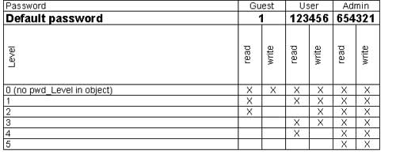
updating of the novaNet driver
sub-applications numbers can be written down to AS
toggle function included (light switching, stores a.s.o.)

EYT250: what`s new?

EYT 250 new service release 1.2.2
- an alarm is indicated by a flashing red LED light.
- more quick access to the pictures, less flickering of the touch-screen
- with “dummy.xml” an application can be started without an AS-conn.
- The EYT250 can read the AS- time. The AS and synchronizes each 30 minutes the time of the EYT250
- Set and reset function of counter values
- Filter functions:
AS filter (device.txt): single AS selection 3,10,45
from.. to.. Selection 46-123
Application-filter
without standard application (name of application)
with standart application (houseadress of AS)

Historical data will come in a later version (vers.3) end of the year
Other languages will come also end of this year

EYT250: sockets

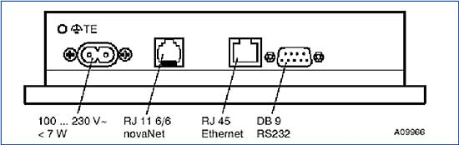
1.) 0386380 001 connecting cable 230V

2.) 0367862 002 connecting cable EYT250 -> nova AS

3.) xxxxx „crosslink“ cable EYT250 -> computer
4.) yyyy DB9 „zero modem“ cable EYT250 -> computer

two female plugs, wiring:

5 to 5
3 to 2
2 to 3

Roadmap EYT250
As of January 2004
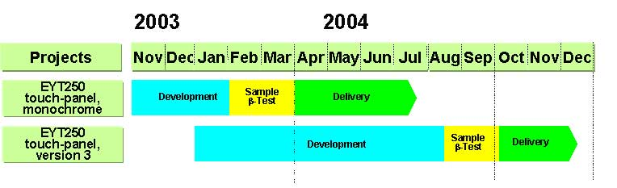
typical application............

EYT250-touchpanel
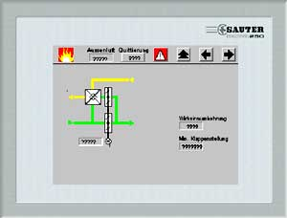
screen overview novaclim screen plate-heat-xchanger

screen cooling coil
screen heating coil

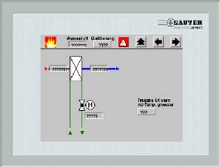
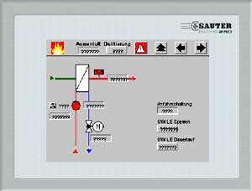

screen fans
screen setpoint
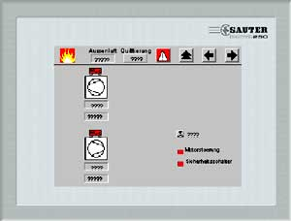
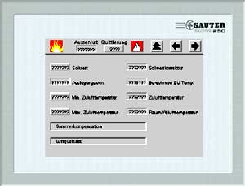

screen summer-comp. screen FAK
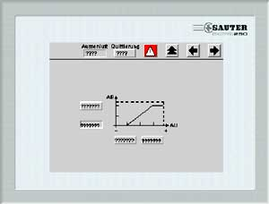
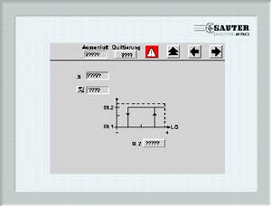

overview parameters
parameters heating coil
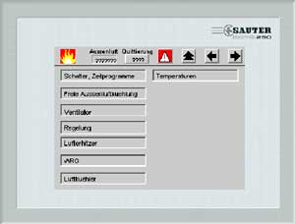
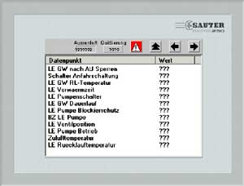

control parameters service address
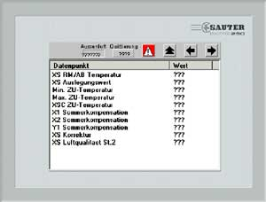
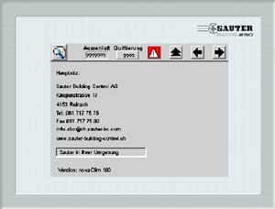

service tel.-no
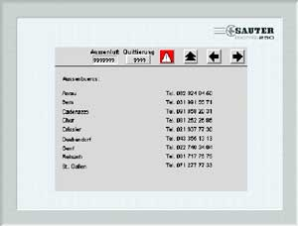

State of the Market-Introduction novaFlex
- Flyer:
in English, French and German available
- Demo-Case (available now!):
novaFlex and EYT250
- NSO prepares some basic models for heating
- NSO prepares some basic models for air-conditioning
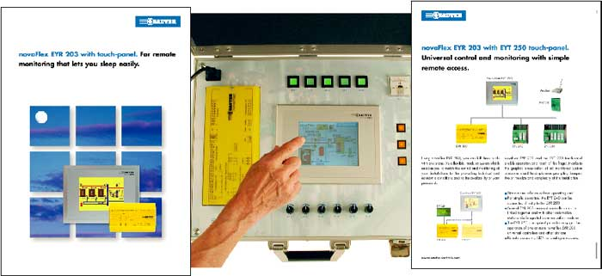

Fixed NSO applications
What do you need:
- Process-plan
- Tested project data of the application created in CASE Prj
- Tested project data of the application created in CASE FBD
- Wiring-diagram
- Function description
- Pictures and texts in original language for EYT250
- Structure of the pictures (operating concept)

