Replacement of equitherm® EQJW 90

today: EQJW90
tomorrow: EQJW95
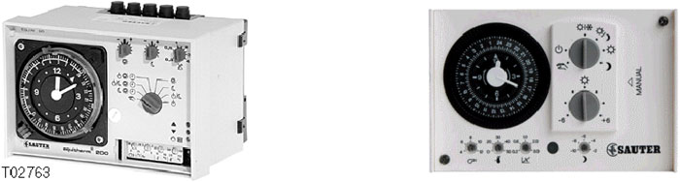
available now !
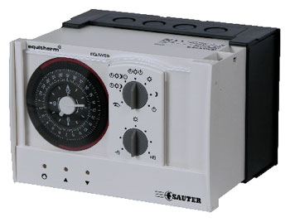
The new heating controller with analogue user interface

Documentation & information

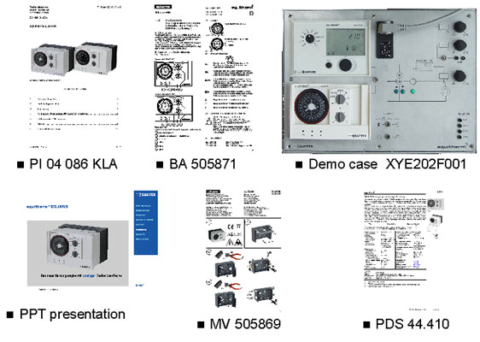

Replacement of equitherm® EQJW 120
Today EQJW120:

tomorrow:EQJW125

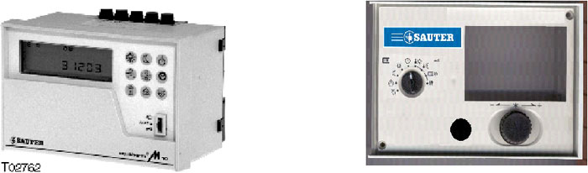

equitherm® EQJW 125

available soon
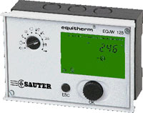

The new heating controller with digital user interface

Communication feature
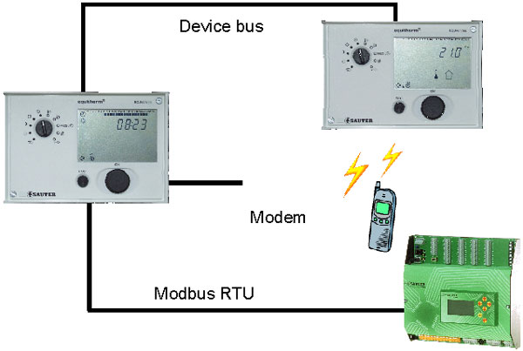

Schedule for the product range
