
Sauter’s BACnet stations: new features in version 2

Complex objects, such as:
• trendlog
• loop
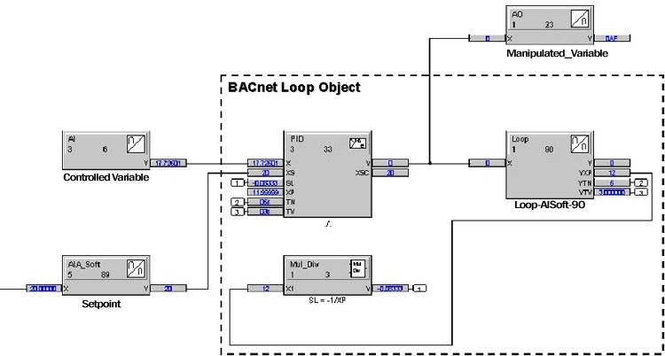

Client functionality on automation level
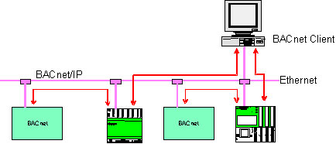

Connection of one BACnet station

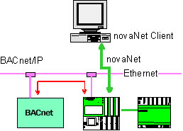

Limited to 100 data points

Use of existing network structures
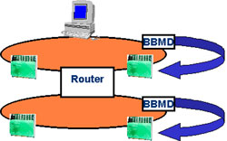BBMD clears the hurdle of standard Ethernet routers

