
The TU Darmstadt: a fine example of open communication with BACnet
Presenting the project

< Old main building

Architecture
& technology
through
the ages

< New admin building

Sauter won the order because of its BACnet competence and experience based on more than 100’000 BACnet data points

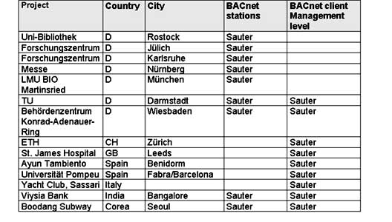
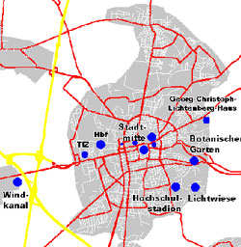
Layout and key figures

Gross surface area:330,000 m2
Energy consumption, heat: 78,000 MWh
Energy consumption, power: 35,000 MWh

Concept and topology
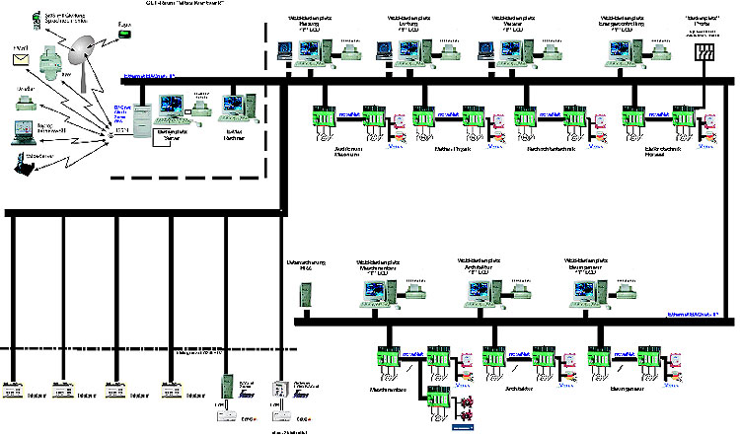

Automation stations and outlying operating stations at the ‘New Town Centre’ site

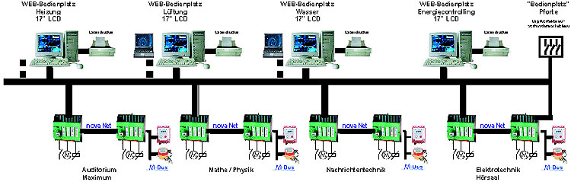

Automation stations and outlying operating stations at the ‘Lichtwiese’ site

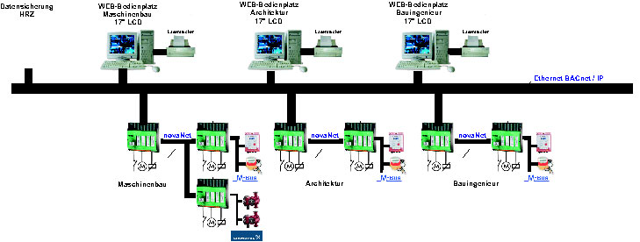
BACnet automation stations from Kieback & Peter and the linking of TAC equipment

Ethernet BACnet/IP
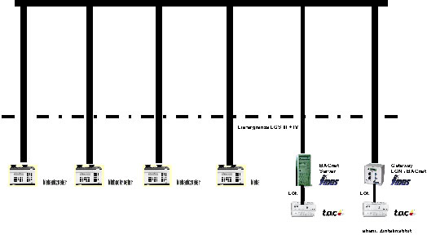
Linking of TAC equipment to BACnet
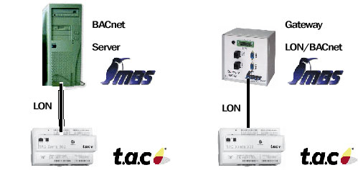

does not have its own BACnet solution, so always has to use a gateway.

Management level with alarm server
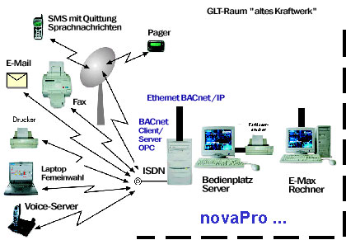

•Alerting via
 e-mail and SMS

•Special feature
The hourly records, which are modified daily, are sent ‘electronically’, as a .csv file, to the BMS, where the associated objects of the BACnet scheduler/calendar are automatically generated.

BACnet overcomes the Ethernet router
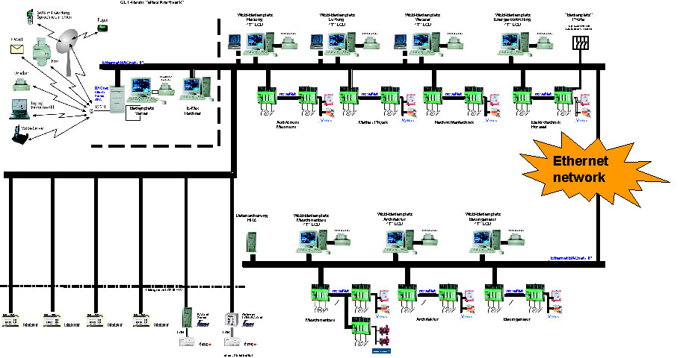

Ethernet and broadcast
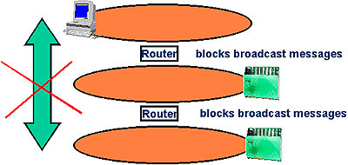

•In large networks, the various parts of the network are usually connected by IP routers.
•BACnet often uses broadcast messages, i.e. messages sent to all network participants (network management: Who is/I am; Who has/I have)
•IP routers, however, block the transport of broadcast messages, i.e. no link is possible (firewall effect).

BBMD: the solution
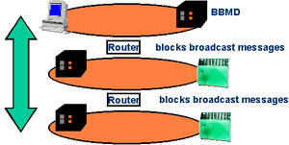
•A BBMD packs broadcast messages into IP packets and sends them to a remote BBMD.
•A (local) broadcast is then sent from there.
•The same procedure applies to the response telegram; in this case, the remote BBMD sends an IP packet to the local BBMD.
BBMD = BACnet Broadcast Management Device

•A BBMD does not necessarily have to be a separate device.
•This function can also be integrated in the BACnet automation station and is then activated in one station per subnet.

EYK 220 and EYK 300
have this function in software version 2.

The view ahead

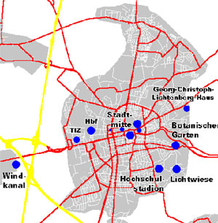

•The project is being continuously expanded as other sites are added.

•As the supplier of the management level with novaPro Open as a ‘genuine’ BACnet client, Sauter is in a favourable position.

•Value of original order was €2 million; with the extensions that have already been confirmed, the final cost (as things currently stand) of the first stage of construction will rise to approx. €3 million.

