
BACnet in project tenders

Why BACnet ?

It gives us the possibility to interoperability (open systems)
We follow the market trends (ASHRAE)
*Became worldwide (American and European) standart
*We can enter in projects from the competition (modernization)
*New market segments are open for us :
Systemhouses which provide neutral SCADA systems
Facility Management Companies

When do we offer BACnet solution?

*In case of integration requirement.
*For new buildings (vertical or horizontal integration)
*For existing projects/buildings (for example : TU project /TAC etc...)

What do we have for BACnet solution ?
Integration on both automation and management level.
*Driver and native BACnet stations.

What do we need to offer for BACnet integration ?

*We have to ask for the PICS(protocol implementation
conformance statement) and BIBBS
*Compare with our PICS and BIBBS.
*Questioning the convenience.
*Declaration of the responsibilities.of both sides!!!!!!!
*Which data should be integrated. Concrete point analysis

BACnet - Description and documentation of the interoperability

•The Protocol Implementation Conformance Specification (PICS)

- Conformance classes
- Functional groups
- Services
- Objects and their properties

• The BACnet Interoperability Building Blocks (BIBBs)

The PICS of the EY3600 BACnet station
(Protocol Implementation Conformance Specification)
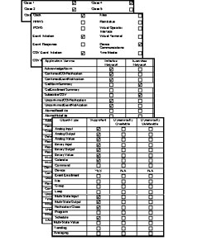
Conformity class 4

Special feature: changes made to
process variables are transmitted
automatically to the client

Functional groups

- Time
- Event initiation

- COV event initiation
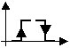
- Device comm./management
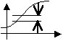

Why SAUTER?

*Experience
*Flexible solutions (management and/or automation level)
*More functionalities (calendar, trendlog, loop objects...)
*Know-how and technical support.
*European BACnet organization member (BACnet interest group)

What are the advantages of BACnet card (EYK300) for Novanet ?
*The possibility to upgrade novaNet into BACnet.
*We can offer cheap solution on novaNet.
(through card or compact station)
*Futureproof and modular solution for BACnet.
*Upgrade into BACnet without any engineering cost.

EYK300 BACnet-DDC from Sauter

