
novaFlex EYR203/207 with Touch Screen Panel
for boiler and heating applications
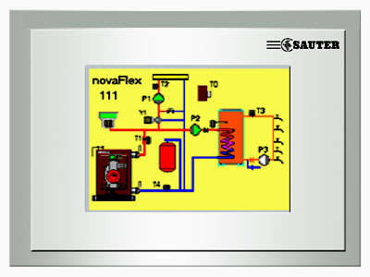

MAIN FEATURES
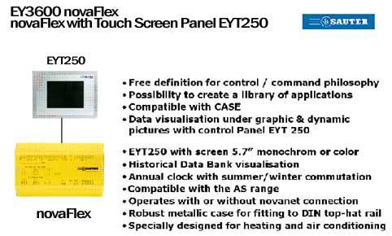

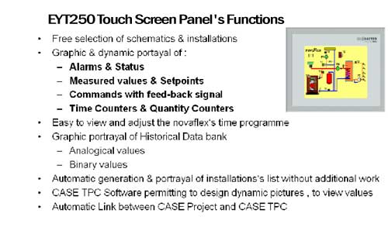

WHAT ARE THE CUSTOMERS EXPECTATIONS?
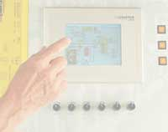
•Easy to use on-site user surface
• Self-explanatory operation
• Editing of plant graphics / lists, time programs
and trends
• High comfort level, clear display, 256 colours
• Standard proofed Sauter solution for all applications
• Outstanding price performance ratio
• High reliability and low maintenance costs
• Speed of delivery
• Modern elegant design
• Fitting: front cabinet or DIN rail

USP-Unique Selling Propositions
•Excellent engineering tool CASE TPC-software for creating the plant graphics, dynamisation and link to the corresponding data points
•Interface to CASE FBD
•Symbol library for function groups
•Main data point attributes can be imported from CASE FBD
Automatic capture of all ASs connected to the network
•Event orientated data transmission
•Portrayal of data in list form without engineering
•Large User memory- 8MB flash, 8MB RAM(1,4 MB for user data)
•Operating system: Linux
•Password protection( 6 levels)
•Lightning protection

NovaFlex EYR207 I/O controller with EYT250 touch-panel , allows solutions that use the full optimizing potential of the heating systems at all times
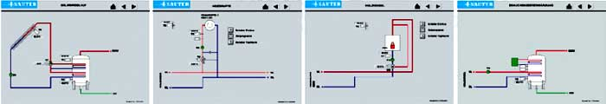
Display of plant values and conditions Weather dependent flow temperature control
Output of switching and setting commands Control of boiler and return temperature
maintenance
Password protection with different authorization Recording of the operating times of pumps and boiler
Display and altering of the time program Command execution monitoring
Display of Ass trend (HDB) in future Collective alarm reporting
Alarm representation in list form Solar heating system application
Calendar with special days

How we can reach maximum of customer value
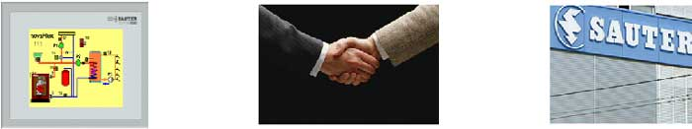

PRODUCT BENEFIT RELATIONSHIP BENEFIT BRAND BENEFIT

Benefit of our solution
Client’s customization
Functionality
Price
Speed of delivery
Product’s reliability
Maintenance costs
Design
Services during sales
After sales services
Quality of relationship
•Do what was promised
•Do it on-time
•Take Customer’s point of view
Staff’s availability
Relationship durability

Swiss quality
Brand image confidence
Good references

Sympathy “ on first sight”

SALES CHANNELS FOR novaFlex WITH EYT250
Mechanical and electrical contractors of BMS installations
•On -site operating station in plant rooms
•Floor-by-floor display in large projects with individual room control( room temperature, occupancy etc.)
•Reformation of the existing BMS installation- upgrading of the existing Ass with the Touch- panel
•Replacement of novaFlex + EYT240 with a pleasing solution with full graphics

Installators
•Information centre in gatehouses, apartments, villas, residential houses etc.
•Operation station in small projects with the option to be upgraded in the future
•Replacement of solutions with QRK151/201 and RRK100 with novaFlex and Touch Panel
•Demand of the Client to link standard stand-alone control systems to the EY3600 at the future

Facility Management companies
•On-site operating station with remote access for easy use of unskilled people

OEM
•On-site operating station for boilers, cooling machines, AHU’s etc.

•
District heating companies
•Remote on-site operating station
•“System houses”- as stand alone unit

Documentation for nova flex and marketing promotion
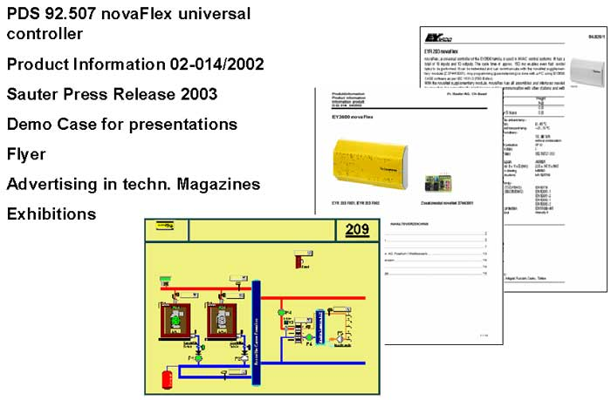

DOCUMENTATION FOR TOUCH PANEL AND MARKETING

Flyer- German, English and French 70009960001/002/003
Demo coffer with novaFlex and EYT250
PDS 92.750

Power Point presentation
Product information 03-054
Exhibition
CD-ROM
Information on Sauter intranet

