Sauter products for the DDC Room Management

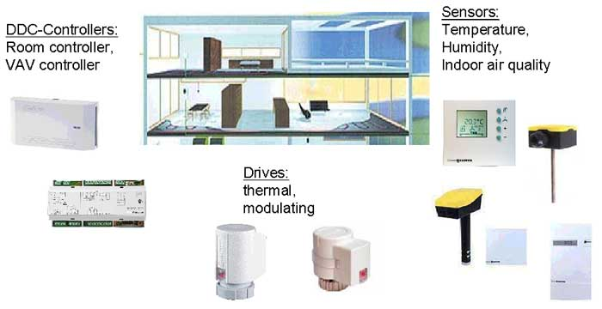

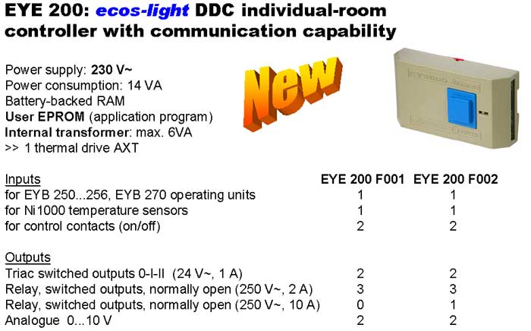

New product features and advantages

Power supply: 230 V~
Internal transformer: max. 6VA
>> simple to install = more profit

User EPROM
Standard applications with parameter setting program (FBD)
>> simple selection + simple to put in operation
>> Focusing on System Houses and OEM customers

EPL 2004
EYE 200 F001 EUR 315,00.-
EYE 200 F002 EUR 343,00.-

Delivery April 2004

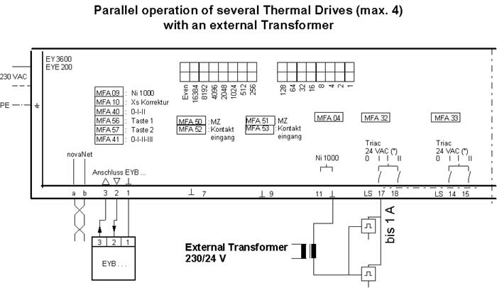

Solution using the continuous drives (with positioner) for unit valves (VUL / BUL)

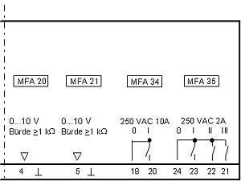

Each output Max. 15 AXS111S
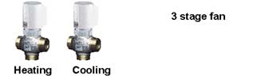

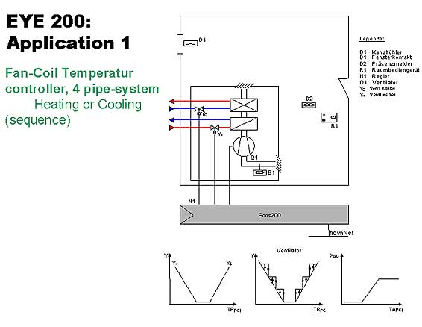

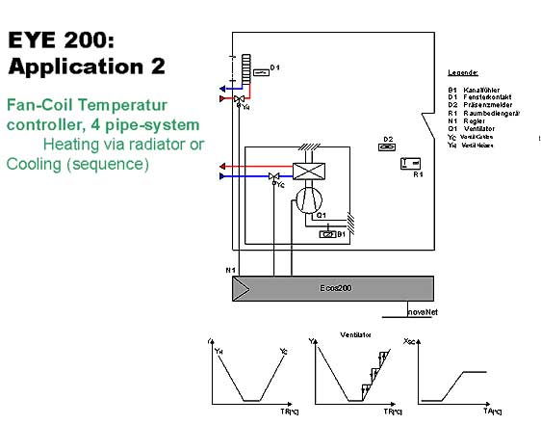

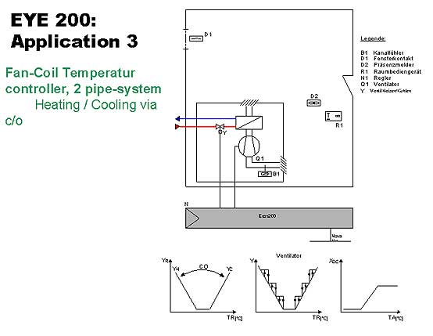
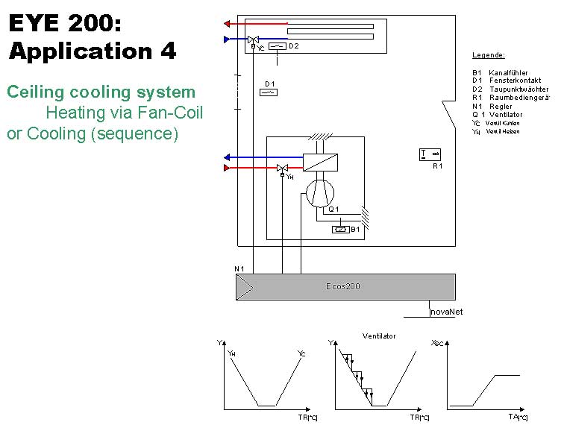

Ecos - room operating units
