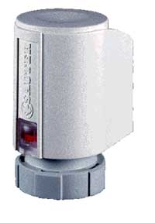

New AXS111S regulating drive
CONTINUOUS
0...10 V/10...0 V control signal

AXS111S F202

With new design and stroke control

Works silently

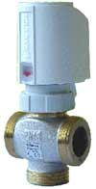
Features
One version for 0...10 V and 10...0 V.
Action can be changed by connecting accordingly

High power with 125 N of pushing force.
The strongest continuous drive in his class

With its spring return, the valve closes in the event
of a power failure

More stroke with 4.5 mm.
Without competition in this range and price class

With 4 mm stroke.
For Sauter 2-way VUL and 3-way BUL valves

No problem to combine with other valves
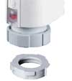
With high stroke and pushing force,
combination with competitor valves is possible
With new design
Customer’s logo is possible
‘Plug & play’
Simple to fit
Ring with bayonet stopper
Fit the ring to the valve
Put the drive on the ring

The running time and the stand-by mode

Fast running time, after starting from cold, 25 s for 1 mm of stroke

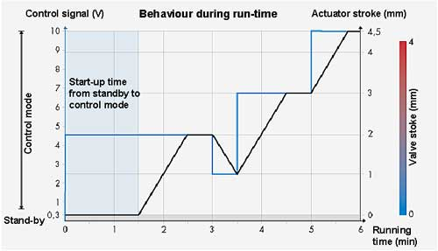

The control system

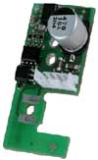
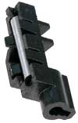
Converts the 0...10 V or 10...0 V control voltage
into a 2-point signal

The magnetic sensor monitors the stroke and keeps
the drive in the desired position.

Thanks to magnetic-sensor technology, it is not necessary
to re-adjust daily or to move to a zero position;
parallel operation is guaranteed.

Goes to stand-by mode as soon as the control voltage falls below 0.5 V or,
in control action 2, rises above 9.5 V

Characteristic and direction of operation

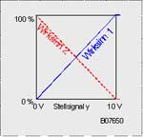
The actuator has a linear characteristic.
The resultant characteristic for the valve–drive combination as a whole is always that of the valve.

One actuator for two versions:
Direction of operation 1 or 2 can be selected at the power cable: therefore, one drive for two versions.


The standard power cable, at 2 metres long, is well suited for use with ventilator convectors.

Prices
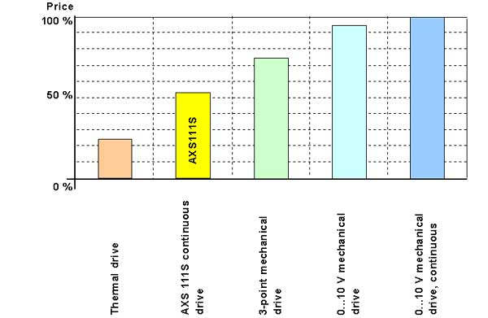

Comparison of prices

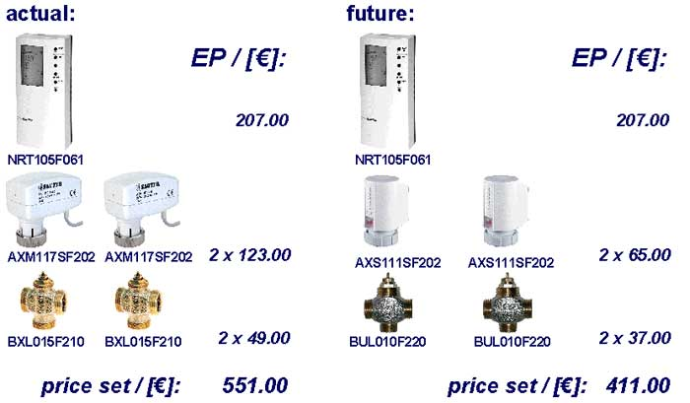

Objective
The European market for continuous valve drives in this class is estimated at 650,000 pcs p.a.
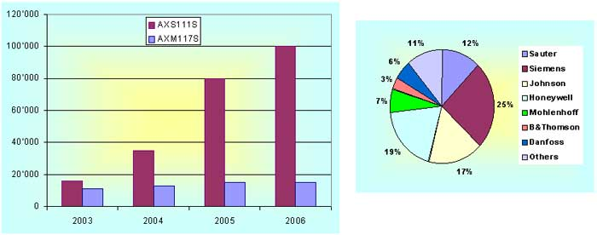

12% equates to 80,000 pcs

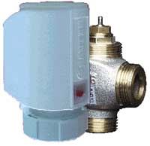
Design and costs

The design – of both the continuous drive and the valve – makes an attractive combination.

A range of products that is suitable not just for the OEM market but for any market.

